Appendix: detailed survey analyses/LNOB results

Contents
Appendix: detailed survey analyses/LNOB results 1
Location of target groups 2
Ethnic origin of the target groups 4
General information 5
General information about Children and persons with disabilities who have guardians (age, sex, marital status, type of disability, relationship to the head of the household, major activities of the child/person). 5
Persons with disabilities 6
Farmers and Women in agriculture and diversification activities 8
Education 11
Children and persons with disabilities who have guardians 11
Persons with disabilities 12
Farmers and Women in agriculture and diversification activities 12
Socioeconomic status (employment, social benefits, health, pensions) 13
Socioeconomic status of Children and persons with disabilities who have guardians 13
Socioeconomic status of adult Persons with disabilities 17
Socioeconomic status of farmers and Women in agriculture and diversification activities (WADEA) 19
Living standard 25
Children and dependants with disabilities 25
Living standard of adult persons with disabilities 28
Farmers and Women in agriculture and diversification activities 31
Discrimination 32
Childcare and school costs. 35
Children and dependants with disabilities 35
Child care provision by persons with disabilities for their children 37
Child care provision by farmers 38
Current position and possibilities for future involvement of persons with disabilities in agriculture and diversification activities 39
Situation with involvement and possibilities for inclusion in ADEA of parents of children and dependants with disabilities 39
Persons with disabilities in agriculture and diversification activities 40
Perceptions of farmers for possible inclusion of persons with disabilities in agriculture and rural development activities. 41
Usage and improvements of Local services/Governance 43
COVID 19 46

The detailed survey analyses are structured by module and target group. Presentation of the results is made by target groups, previously divided in categories (as per modules) that are of particular importance for the target groups. The flow of information is separated into the following areas:
Area | Covered risk factors
Education | discrimination, governance, socioeconomic, status, geography
Socio economic conditions including employment, income, health | socioeconomic status, geography, discrimination
Living standard | vulnerability to shocks, socioeconomic status, governance, discrimination
Child care | socioeconomic status, geography, governance
Discrimination | discrimination
Local services | discrimination, geography, governance
Situation with inclusion and potentials for inclusion of persons with disabilities in ADEA | socioeconomic status, discrimination, vulnerability to shocks
Covid 19 | socioeconomic status

Each section is describing the situation of the target groups by putting accent to issues that cause vulnerability. Results from each question are presented and summary of the findings from series of questions for each section. The questions that were part of the survey modules and synthesised in the sections are noted in the introduction of each section.

Location of target groups

The geographical coverage of the survey included the whole territory of Municipality Resen.

- Children and persons with disabilities

The figure 1.1.1 shows the location of the respondents in the survey according to their place of residence.
Geographical distribution of children and persons with disabilities is on the whole territory of the Municipality of Resen. In spite of the fact that their distribution is all over the municipal territory the highest density of those who were willing to respond to the survey is in town of Resen, while the villages with highest density of respondents to the survey are in Carev Dvor and Jankovec.

The villages where the other respondents are coming from include: Asamati, Rajca, Dolna Bela Crkva.

There were 27 refusals coming from both parents/guardians and persons with disabilities to contribute to the survey. The parents/ guardians who refused to respond are coming from the villages as shown below. However, the most refusals among adult persons with disabilities are coming from the town of Resen.

26% of those who rejected to respond were guardians’ parents and 74% were adults coming from town of Resen. In line with the scope and focus of the mapping process we may say that the parents of the children with disabilities are more open and cooperative, with exception of those 7 based in villages who refused to respond in comparison tothe 39 who provided responses.

The refusal to participate in the survey from village-based parents and guardians indicate the existence of stigma in the villages and general closeness in terms of exposing the children and persons with disabilities to avoid potential consequences. This is indication of urgent need for securing conditions for socialisation of the children within the communities with other community representatives in order to increase the awareness and acceptance.

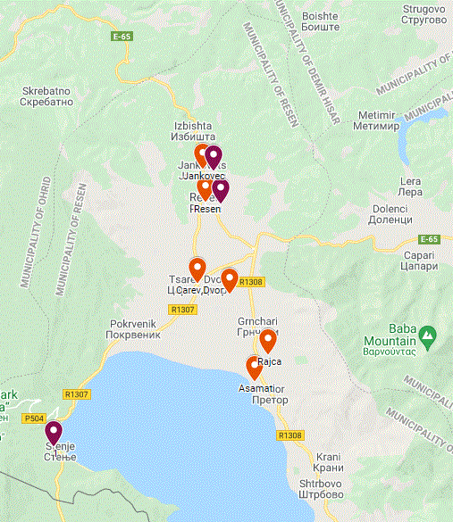 | 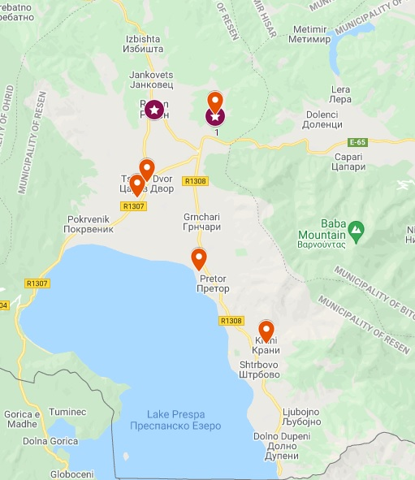
Figure 1.1.1: Distribution of the respondent parents and guardians (orange marks) and persons with disabilities (marked in lilac colour) | Figure 1.1.2: Location of those parents and guardians (orange colour) and persons with disabilities (lilac colour) who refused to respond to the survey
Half of the persons with disabilities refused to respond to the survey. The reasons for not participation were also hardly obtained. The general response was that they simply don’t want to participate in this activity. All reasons that might prevent them are and might be assumptions for the causes of the closeness of adult persons with disabilities including governance, stigma, disbelief, dissatisfaction or simple lack of understanding of benefits from the survey in spite of the fact that they were elaborated to them by surveyors.

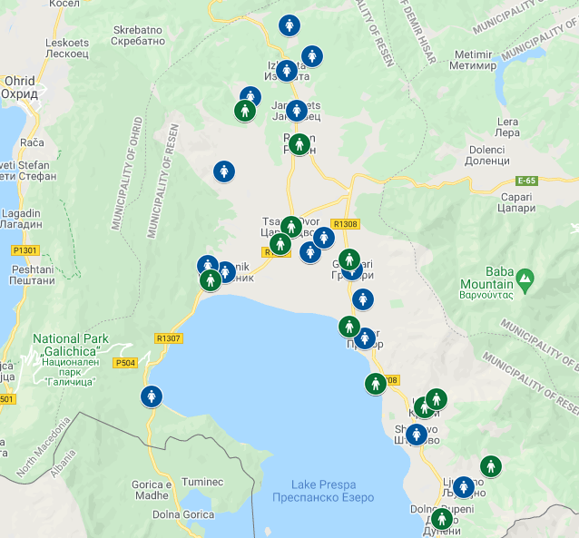
Figure 1.1.3: Location of the farmers by gender who responded the questionaries (women are marked with blue and men with green)
Figure 1.1.3 presents location of farmers and women in ADEA who agreed to respond to the survey. The map presents the location of farmers and it’s divided by sex. This is due to the focus on women and identification of their status and their perception for inclusion of persons with disabilities in the activities on farms, the map shows the gender distribution of the respondents.

Ethnic origin of the target groups
municipality of Resen is an interethnic municipality. The survey included representatives of all ethnic groups according the specifics of the survey. Below is presented the ethnic representation of the survey participants.

Figure 1.2.1 Participants: Ethnic origin of the target groups

General information

This section will provide information and cross questions analyses on data collected from the following questions: Age, sex, marital status, type of disability, relationship to household members, major activities. Presentation of information will be separated by target group in separate chapters.

General information about Children and persons with disabilities who have guardians (age, sex, marital status, type of disability, relationship to the head of the household, major activities of the child/person).

The major interest of the mapping process for children with disabilities is to define the real number of children with disabilities as they are defined within the Law. The general structure of children and dependants with disabilities for whom the survey was undertaken with their parents or guardians show that there are 39 children/ dependants with disabilities in Municipality Resen. There are 24 female and 15 male children/dependents.

In line with the law, the analyses of type of disability will be performed in three age groups: children aged 0-18, 18-26, and those over 26. There are 23 children that are within the age range between 5- 18 years old, and one parent/ guardian of child in the range 18-26. The rest of the children/ dependents are (15) are aged between 26- 69 years of age.

Figure 1.3.2: Number of children/ persons with disabilities according to the three age categories

The first analyses identify the number of children with disabilities that belong to different age groups with different disabilities. This is done in order to provide basis for further analyses in the following sections (education, employment, agriculture, health discrimination etc.) These analyses present density of the children with disabilities in two age groups.
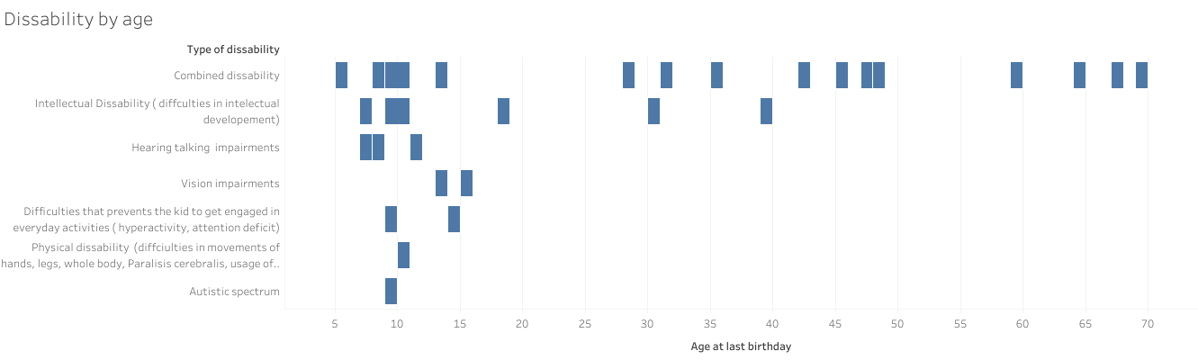
Figure 1.3.1: overview of the structure of children by age and disability

In terms of relationships to the head of the households of families, thirty (30) of the children/ dependents/persons with disabilities have parents as heads of households, two (2) are taken care of by grandparents as heads of households, two (2) are guarded by siblings, one (1) has official state designated guardian, one (1) is taken care of by stepparents, one (1) by the partner and one (1) by a non -relative. One (1) woman is taken care of the husband. Two (2) of the children/ dependants have combined disability and are household responsible themselves. One of the is a widowed woman (age 67), and one is a man is who lives alone (aged 48) due to parents’ death and he does not live with designated guardians.

Figure 1.3.3 Relationship with the representing guardian

There are not recorded child marriages among children and dependants with disabilities. There are two (2) married persons which belong to the category over 26 years of age. One is a woman ( aged 47) for whom the husband filled the questionnaire and they are in traditional marriage. The second one is the widowed woman (aged 67) who remained as sole head of her own household and have combined disability.

Persons with disabilities

Adult persons with disabilities who participated in the survey are in age range between 20-69 years of age and have physical disability. The number of persons with intellectual, combined and disabilities related to autistic spectrum is lower for 27%. Therefore, the reflection of the findings about this group will predominantly reflect the needs of persons with physical disability.

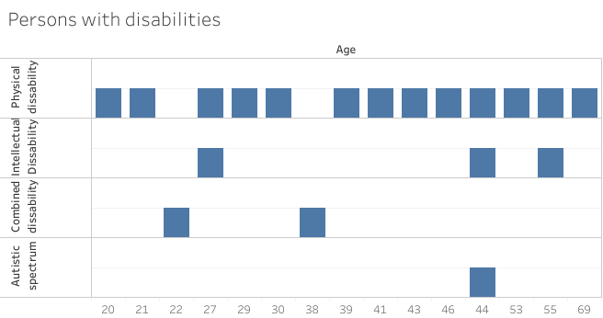
Figure 1.3.4: Age distribution of adult persons with disabilities

The survey was accepted by 15 male and 7 female respondents. The check-up of the position of the persons in the family, the analyses show that women if they are married, identify themselves only as related to the head of household, while married man identify themselves as heads of households or as son to the head of household. This indicates a specific socioeconomic situation of persons with disabilities which will be analysed deeper in the section socioeconomic analyses.

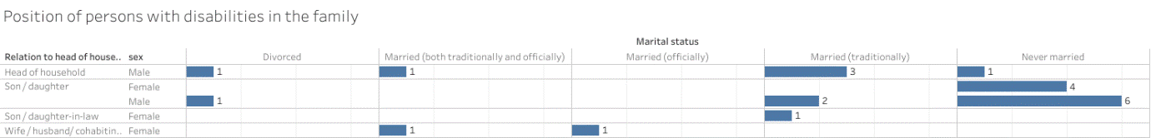
Figure 1.3.5 Family status of adult persons with disabilities

Occupation of persons with disabilities who are part of the survey is divided between those who are unemployed, those who are full time employed and those who are working part time jobs or are retired.

Figure 1.3.6: occupation of persons with disabilities

Farmers and Women in agriculture and diversification activities

The survey included 75 respondents engaged in agricultural and diversified economic activities, there are 51 women and 24 men, who took part in the survey.
The age distribution of these persons is within range between 21 and 75 years.

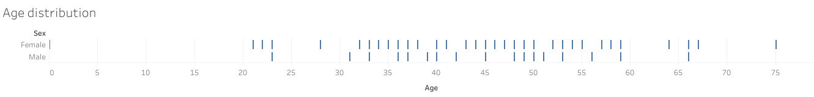
Figure 1.3.7 Distribution of men and women by age among farmers and women in ADEA

The martial status among women in ADEA is that women between 21-37 years are never married, women between 38-66 are married, and the women over 66 are widowed. This indicates that the women involved in farming and diversification in Municipality Resen are not subject to child or early age marriages.

The question about what is the current major activity of the women provided responses which indicate that they do not recognise their input in agriculture and diversification as major activity, rather they identify their activity as self-employed, and full-time workers or even unemployed.

Only four women, identify their major activities in agriculture: one identifies major activity as paid job, 3 as unpaid workers on family farms. The details on self-identification and linkage to agriculture in details is presented in the section employment.
In spite of the low first identification with the agriculture, while asked to determine the sector and work type, they identify themselves as self-employed in agriculture (12 women), employed full time – only two of 24 women declared that they are employed on family farms. Two state that they work full time without declared status on family farms, one declares that works full time in public institution in agriculture sector. One states that does not work, but indicates the agriculture sector as her employment sector and another one states that she is not employed but works as individual farmer. The total number of women who indicated any engagement in the agriculture sector or agriculture is 26 women.

Paid / unpaid jobs | Type of employment | Sector | Number of women
Paid | Self-employed | Agriculture | 5
Paid | Unspecified | Agriculture | 5
Paid | Full time employed | Agriculture | 1
Paid | Individual farmers | Agriculture | 5
Paid | Employed/without specification of job type | Agriculture | 2
Paid | Unknown | Agriculture | 1
Unpaid | Works on family farm | Agriculture | 1
Unpaid | Student on family farm | Agriculture | 1
Unpaid | Retired housekeeper works on family farm | Agriculture | 1
Unknown | Full time on family farm | Agriculture | 1
n/a | Unemployed | Agriculture | 2
Paid | Self employed | Unknown/ agriculture mentioned as additional activity | 4
Paid | Full -time employment | Unknown/ agriculture mentioned as additional activity | 4

The situation of those who have not mentioned agriculture 23 as primary employment, but declared their involvement in agriculture activities later are owners of land and their structure is as follows:
Paid / unpaid jobs | Type of employment | Sector | Number of women
Paid | Full time | Public | 4
Paid | Full time | Food processing | 9
Paid | Full time | Not specified | 6
Unpaid | Unemployed student |  | 1

Three (6%) are engaged in ADEA /tourism industry: one works unpaid job in the family tourism business, one is self-employed in her own tourism business. one is retired and still works in family business.

Paid / unpaid jobs | Type of employment | Diversified Economic activities Sector | Number of women
Paid | Self employed | Tourism | 1
Unpaid | Full time work | Tourism | 1
Unpaid | Retired but work | Tourism | 1

These numbers indicate relation between women who have registered land on their own name and their major occupation, vs those who are engaged in agriculture and are owners of land and employed in the sector.

In determination of type of relation with the head of the household, majority of respondents identified themselves as wife/partners to the heads of households. Only 3 women identified themselves as head of households out of which two are widowed and one is retired and is 67 years old.

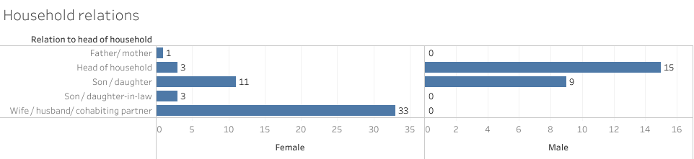
Figure 1.3.9 Relationship with the head of household of men and women in agriculture and diversification activities

There are three women who identify themselves as daughters in law - they are all owners of land). When going deeper into characteristics of these three women it can be seen that one works on the family farm and have additional income as freelancer. The other one work in another private company. And the third is unemployed in spite of being owner of land.

This indicates that in spite of the notable number of women who are either employed or registered farmers (own the land), they do not identify themselves as heads of households. This indicate that they either do not carry the major provisions for the family or even if they do traditionally, they put the heads’ role into men hands.

Education

In order to identify: education status, involvement in educational or care activities, level of education, reasons for leaving or not attending schools or day care centre and reasons behind it. The corelation of the questions and risk factors that determine LNOB groups for this section is:

Modules | Risk factors analysed
Use of care facilities | Governance
Level of education | Socioeconomic status
School attendance and dropouts | Discrimination

Children and persons with disabilities who have guardians

The question for definition of the everyday activities had purpose to identify the status of the child or person with disability to be defined by her his parent or guardian.

The majority of the children/ persons who have guardians are in the education cycle depending on their age.

- Age5-18: There is one child (aged 5) that does not attend any schooling or care centre and two children (aged 7 and 16) from villages that do not attend any school. One of them (aged 7) attends the day care centre. There is in addition one child that attend both the school and day care centre. Thirteen (13) are attending regular primary school, two (2) attend day care centre, one (1) is attending both primary school and a day care centre, and one (1) is attending vocational high school.
- Four children have declared other. The later elaboration on the type of schools include: three (3) kids who are attending specialised schools and one (1) child who is attending school for children with hearing and vision impairments.
- Age 18-26: There is one person that falls in the category (age 18-26) who is attending the day care centre and has not attended any education before.
- Age 26+: Three (3) who attend the day care centre.
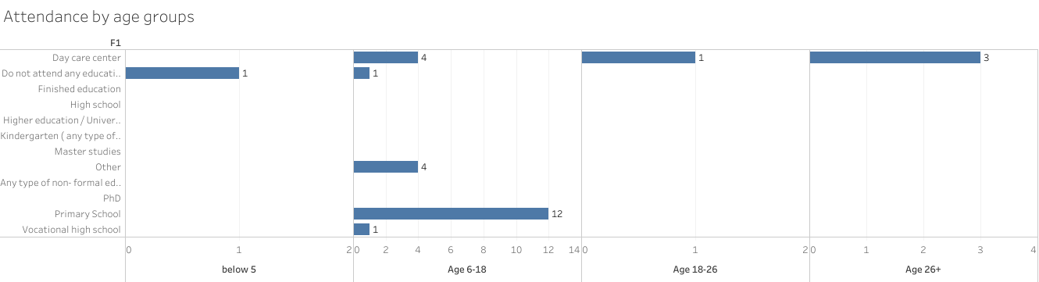
Figure 1.4.1: Attendance at education activities by age groups

In regards to finished or not finished education cycle, In the age group (age 26+) there are three persons (3) who completed education and 3 of them defined the completed educational as vocational high school. Eleven (11) have uncompleted education, neither attended any. The reasons mentioned behind leaving school include: illness (5 persons) and one (1) did not get well with the teachers, the rest have not provided information why they left school.

Figure 1.4.2: Education level among dependents over 26 years of age

Persons with disabilities

The first section of the education is related to the ongoing attendance at educational institutions or organisations. The current situation is showing that there is only one person that use the services of the day care centre. Majority (17) of the persons declare that do not attend or finished education cycle.

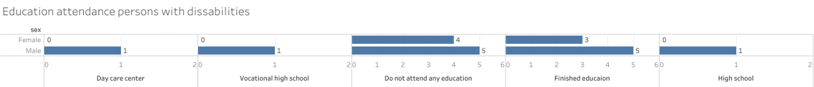
Figure 1.4.3 Attendance of education among persons with disabilities aged 18+

Out of those who confirmed that do not attend education that’s due to their illness in the past, or don’t find value in education.

Level of education
From those who reported finished education here are seven (7) persons who have completed secondary education (including vocational education) and one (1) who have obtained master degree. The rest of the persons do not have finished or have not responded about the education level.
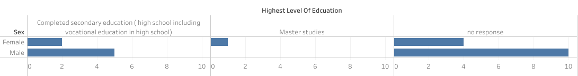
Figure 1.4.4 Level of education among persons with disabilities

Farmers and Women in agriculture and diversification activities

The educational structure among the farmers is relatively good. At the moment of the survey the majority of the respondents have finished the education cycle. There are 58 who already finished education, 7 who do not attend. The structure of those who attend the education in the moment is that 5 women attend university, 2 women attend non formal education, 1 men attends high school, 2 women attend VET school and 1 is attending some other undeclared education.
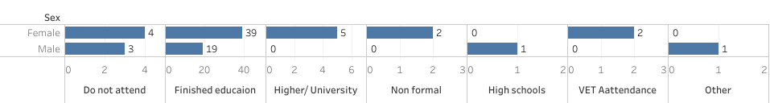
Figure 1.4.5 Men and women in ADEA current education status in terms of attending, finished and not finished education
In regards to the obtained training in ADEA, three (3) women finished high school/ VET for agriculture. The other obtained agriculture skills on LBD principle.
Level of education among the farmers, is characterised by predominantly finished Secondary Education including Vocational Education.
Level of education among women who are registered owners of the agricultural land or are part of family farms or registered farmers in Municipality Resen is relatively high. Eighty percent (80%) of the women have obtained high school or university degree. Forty percent (40%) have secondary and 40% higher education, while 18% have finished primary, or some kind of non- formal education. Only 2 % are left without education and these 2 % belong to women over 65 years of age.
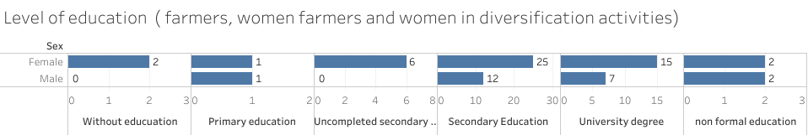
Figure 1.4.6: Level of education among men and women in ADEA

Socioeconomic status (employment, social benefits, health, pensions)
This section provides responses and analyses on the questions which defined the socio- economic status: Employment status, official employability assessment, doing paid work and the status of the paid work during the last year, economic sector of involvement; for unemployed persons the status with registration of unemployment, looking for jobs, unemployment benefits.
Situation with health and health insurance, accessible health services, health and its effects on working capacity are also part of this chapter.
In addition, this chapter also analyses presented data about social benefits and pensions, their availability and usage.
This section also includes analyses about information about income generation activities and information on values of generated income during last months or year.

Socioeconomic status of Children and persons with disabilities who have guardians

Employment and income generation activities
This target group include children for whom this section is not applicable. However, this target group include dependants who are aged over 18 years and 26 years and who might be employed and secure their income. The activities that occupy the most of their time cannot be defined as occupation in all cases. But as expected for this age group, majority are students except one child who is reported out of education.

.
Figure 1.5.1: Major activity of children and dependents
For the age groups that may be employed (18+ and 26+), the dependants are either unemployed, too old to work or retired. In general, the employment status of dependants that belong to the age group over 26 years of age, can be characterised as bad.
There are four (4) employable persons. Two (2) of them are officially assessed as employable but are unemployed.

Figure 1.5.2 Employability status of dependents who are over 26 years old, as reported by guardians

The remaining eleven (11) persons are officially assessed as unemployable. Six (6) persons have not undergone employability assessment. For five (5) persons guardians responded that they are not working, nine (9) persons guardians responded that are fully unable to work due to their disability. To cope with unemployment and find jobs through the system, three (3) unemployed persons are reported to the public agency for employment. The reasons why the others are not registered are: their age - they are too young, they are assessed as unemployable, are not assessed but are unemployable, they are retired.
One dependant is reported that is doing informal work. Only one (1) person is declared as employed in the sector of agriculture but is not registered.

Majority of the children and dependants do use social benefits. The support for care is received for 18 children and dependants/persons with disabilities. Six (6) families received financial support from the government, and only one family reported that received heating support during the previous year.

Family members refuse to report additional income generation activities. There are thirty (30) or 76% of parents and guardians who refused to respond to the initial question if the family is involved in any additional income activities. Nine (9) or 23% have not responded at all to this question.
Nevertheless, later responses on the questions about agricultural activities, 31% of the families reported that the family is involved in agriculture. And their main agriculture sector is fruit growing (21%) of the total number of respondents, 8% are reported as livestock breeders, 3% own beehives and 3% have crop production.

Health conditions and access to health care
The health conditions of the children and adult dependents is different and is depending on specifics of the disability and it is accompanied by the additional health conditions they have.

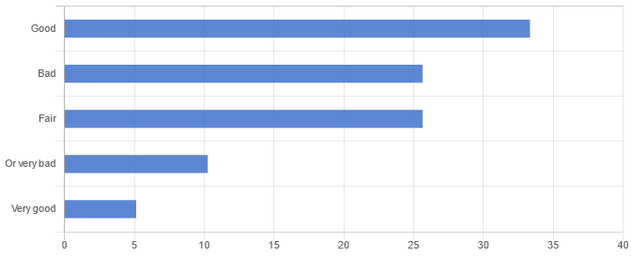
Figure 1.5.3 Health condition of children and persons with disabilities who have guardians
Health insurance
The parents and guardians declare that 77% of children and dependents are covered with health insurance. There is a significant number of parents 18% that don’t know or refuse to respond to this question. The child of a family that deals with agriculture falls into this category.

Remaining persons are children of unemployed parents and dependants over 26 years of age who are women, who are taken care of by their siblings, officially assigned guardians, partners or parents. These 5% of the persons who do not have any health insurance includes children and dependants whose parents and guardians are unemployed and declared grandmother’s pensions as the only stable income in the family.

Figure 1.5.4 Health insurance among children and persons with disabilities who have guardians

Formal disability assessments had been carried out for 92% of the children and dependants. Those who have not been assessed (5%) include two boys aged 9 and 14, and (3%) one person aged 67 years who is dependant and for whom the guardian is not aware if official disability assessment has been carried out.

Figure 1.5.5 Confirmation about undergone official disability assessment
Unemployment benefits are received by only one person. The other three are not receiving any unemployment benefits in spite of the fact that two of them are reported in the employment agency.
There are 22 persons who receive support for care.
The two recipients of pensions are receiving family and an old age pension. There are two other families of children who report that the only stable income in the family is the pension from the grandmother.

Socioeconomic status of adult Persons with disabilities

Almost half (47%) of the persons with disabilities who took part in the survey are not working. There is a significant number (37%) of those who work full or part time. There are 16% who declare themselves as a homemaker, live with inherited pensions or do jobs like recycling iron.

Figure 1.5.6: Status of persons with disabilities
Initial aim in this mapping process (for persons with disabilities) was to determine employment and employability status. Also, what is the situation in relation to their employability and employability assessments. To respond to the initial aims, and to provide sufficient analyses the employability status is cross checked with occupation of the persons with disabilities.
Official employability assessment is performed for 68% of the adult persons with disabilities. There are 23% who are assessed as employable and 18% who are not assessed but declared as employable. From those who are assessed as employable, 5% (one person) with combined disability does not have paid job, and 23% who have physical disability (five persons) are employed. The data analyses showed that those who have not undergone employability assessment do not report paid jobs.
The employment is permanent for 14% (three persons), while 9% (two persons) have temporary employment agreements. The most educated one holds a master degree, is assessed as employable but is unemployed. Employed are the persons with finished secondary education. Part (5%) of those who are officially assessed as unemployable are doing jobs in the non-formal sector.

Figure 1.5.7 Employability assessment of adult persons with disabilities

Declared working hours reflect the declared employment status of full and part time engagements.
Average working hours | Standard deviation
34.00 | 13.42

Table1: Working hours by adult persons with disabilities

The survey results indicate that private sector in Municipality Resen employs persons with disabilities. There are 14% who are employed in business sector owned by other persons, while 5% work in public institution (Municipality). One person (5%) is declared as a freelancer that does work occasionally, but is not officially employed.
Food processing industry employ 5% of employed persons with disabilities, and sectors defined as “other” employ the rest of persons. The sectors declared as other do not include agriculture, and diversification activities such as tourism, catering, crafting etc. So there is no employment of the persons in ADEA.
In relation to the contracts and benefits that go along employment, like pension and health benefits, persons with disabilities who are employed in other persons business declare that they have covered employment benefits. The one that’s self-employed Is not covered with social benefits.
Employed persons and the freelancer do declare their monthly income, which is below the average net national income .

Average declared income among persons with disabilities in Macedonian Denar | Standard deviation
12 379.80 | 8 284.81
Table 2: Average net income received during the last month

Unemployed persons do not look for jobs and receive support for care. Reasons behind not registering in state employment agency are their inability to work, and beliefs that there aren’t jobs available. There are only 18% (4 persons) who are registered at state employment agency. One who is employable (5%) do not register in state employment agency. The support for care is used by all, including persons who are unemployed and one of the employed persons. Additional income gained from the additional activities in families such as agriculture, resale of purchased goods and freelancing is reported by 19% of respondents. The rest of the persons (73%) refuse to respond to this question, and 8% have not provided any responses to this question. The type of the activities where they are involved include: resale of purchased good, farming, freelance work.

Figure 1.5.8 additional income generation activities in families of adult persons with disabilities
Since this is first question asking about income generation in the family, persons refused to respond. The cross-check question about the involvement in ADEA, number of persons who reported additional activities increased from 19% to 37%.

Reported income from additional activities varies depending in reported activities. There are 13% who haven’t reported additional income generating activity, but later reported income from additional activities in the frames of 100-500 euros per month.
Those who reported additional income generating activities do not report the gained income. Only 9% reported generated income between <100-300 Euros per month, during the last year.
The surveyors confirmed that the reasons behind not reporting income and additional activities is the fear of losing the financial support for care (which is less than 50 Euros per month).
Majority or 82% of adult persons with disabilities are covered with health insurance. There are 9% who are not covered and other 9% who refused to respond/ don’t know. Those 9%who are not covered are either out of job, do not register at employment agency or do not have anyone officially employed in the family. This affects the access to health services as there are 13% who claim that have not received dental and medical service due to lack of health insurance.

Figure 1.5.9 Coverage with health insurance among adult persons with disabilities

Health conditions prevent 27% of persons with disabilities to work. The health conditions include mental health, difficulties to move, dexterity and stamina. These are the same persons who are assessed as unemployable, and these conditions affect their performance and reduce their daily activities.
Almost one third of the persons 23% do not receive any retirement benefits and pensions. There are only 9% who receive both family pensions and benefits for care.

Figure 1.5.10 Pension and retirement benefits

Socioeconomic status of farmers and Women in agriculture and diversification activities (WADEA)

This section presents the findings for the status of women involved in agriculture and diversified economic activities. All (51) of the women who took part in this survey, confirmed their engagement fruit growing activities. Only two of them identified themselves as beekeepers.

Agriculture is primary source of income for families of 15 women. And additional source of income for families of 36 women.

The survey included women who are registered owners of agricultural land but not necessarily have agriculture as primary sector for their employment. This category includes women who are owners of the land but are officially unemployed and women who are owners of the land but they are employed in other economic sectors. In general, the employment and engagement of women in agriculture is reflected by the fact that the women who are owners of agricultural land, sometimes work in agriculture as additional activity and additional source of income.

Figure 1.5.11Major activity/ occupation of women in ADEA

The statistical calculation of the working hours, does not include working hours of:
- women who work as full-time homemaker,
- women who are working on family farms as unpaid jobs,
- women who declare that they do not work but they are involved in the activities on family farms.

This is because they have not declared and do not calculate their working time. This indicates that there are a lot of hours as unpaid job for women, but not only in the household, but also unpaid hours during the work in agricultural activities on family farms.

Average working hours | Standard deviation
43.88 | 5,94
Table 3 Working hours of women and men in ADEA

Among the women who are owners of agricultural land, there are women who are full time employed (18) in public or municipal institutions or companies, women employed (13) in private companies owned by other persons, woman (1) who is employer in her own business with employees, women who are family workers (2) in family business, women (24) who work on farm and women (7) who are schools’ self- employed.

The 13 unemployed women do not look for employment. Only 3 women provided response to the question why they do not look for it, and they noted that they have informal work, that anyway there is lack of jobs available and one do not look for job because she is a homemaker. The rest (10) of the women refuse to respond, or do not identify the possibility to be employed as farmers. There are five (5) women who are unemployed and not even registered in the system as unemployed. Only four (4) out of 13 are registered in the public employment agency. The rest do not report themselves and refuse to respond on the question.

In relation to agriculture and diversification activities the employment by subsectors is presented in chart below

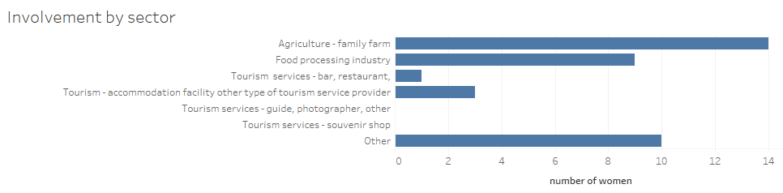
Figure 1.5.12 Involvement of WADEA by major activity

Majority of women refused to declare the income gained from the activities related to agriculture and diversified activities. However, those who reported the net monthly income gained in the last year within the families, from the ADEA where women are also involved, are not obviously managing to secure substantial income during the year. This is due to the fact that there are only 3 women who declared income higher than 1000 Euro per month in the last year in the family. Majority declared income between 500-1000 Euro per month.

Figure 1.5.13 Net monthly income in families of WADEA from additional activities

Average declared monthly income from ADEA  ( in MKD) | Standard deviation
3979.59 | 8311.10
Table 4: Average monthly income in families from ADEA

The survey also determined the active or passive role of women and if women have paid or unpaid work. The factor of primary and secondary source of income activities also determinates the work as paid or unpaid.
The results show that the 50% of women who are actively working in ADEA as primary source of income for families are not paid for their work. 38 % are paid and 13 % state they are just helping, which means that they are not paid as well for the hours spent on the ADEA activities.

Figure 1.5.14 role/ paid work of women in ADEA where ADEA is primary income generating activity

There is significant number of women who haven’t reported if they have social and pension benefits paid monthly. The survey results show that 43% of the women have not confirmed paid social and pension benefits on monthly basis every month during last year
However, they have health insurance paid either on their own name or receive it through the insurance of the husband. The overall analyses in the general data show that the women who are out of work, are homemakers, do informal jobs and other unpaid work and report health insurance on their own name, are registered in employment agency, which provide health insurance for those who are reported as unemployed officially on long run.
This indicates that the women in spite of the fact that are employed or engaged in the activities do not have sufficient social benefits coverage.

However, this does not leave only the women behind, but also a proportion of men involved in ADEA. There is significant number of persons who have not responded to this question at all.
The figures of the overall farmers’ analyses indicate that 56% of the total number of interviewed farmers including women have paid social and pension benefits, However, there is a significant number of 44% in total who do not receive or don’t know. They either do not receive (8%) payments, or fall in category that refused to respond / don’t know. This indicates a serious indication of further investigation and analyses of the situation of farmers in general in regards to their social and health benefits, employment and unemployment benefits.

In line with the above statement the type of employment is the reason why the farmers and women involved in agriculture and diversification activities are not covered with regular social and pension benefits.

Figure 1.5.15 Type of employment among registered and employed farmers in Municipality Resen including men and women

Only seven (7) persons are registered at the employment agency.

In regard to the income there is not sufficient response rate to define the average income due to the fact that 23 respondents refused to respond on the question. Only 3 women and 5 men provided information about their income. The rest refused to respond. This indicates that the women in farming do not want to report the income due to the fact that either they don’t know the exact value, or they do not want to report the income in order not to lose the social benefits (only 3 women declared that they receive financial aid from the state).
In spite of the insufficient information that is contrary to the one elaborated in figure 5.1.13, the table 5 indicates the findings from the Reponses collected both by men and women.

Average income of men and women in ADEA ( in MKD) | Standard deviation
10 549.50 | 12 216.25
Table 5 Income of women and men in ADEA in MK denars

In regard to the health insurance only the proportion of women who have health insurance is higher. The survey analyses show that 71 % of women are covered with health insurance in their own name. This percentage includes women who are registered in the employment agency as unemployed, those working in other sectors than agriculture and those registered as employed in agriculture officially.

Figure 1.5.16 Health insurance among women in ADEA

Two women who are in age for pension do receive age pensions and only one received family pension. The rest are in their active (under 62 years of age).

Environmental problems and pollution are detected as issue by all three groups. There is no crime reported and the municipality Resen is declared as crime free area from all target groups.

Living standard
This section provides information about the living conditions of the target groups. It includes information about the housing as a factor which determines the poverty status, access to drinking water, food security in families, affordable and not affordable status for satisfying basic needs of individuals, access to IT and internet, economic safety, use and available access to services. In spite of the fact that use and access to services fall into governance section the aim is to determine the costs that affect the target groups and families in reaching the basic services in terms of socioeconomic geotagging.

The narrative of this section provides analyses of questions related to 10 modules in relation to the risk factors of discrimination, socioeconomic status, vulnerability to shocks, governance and geography. The linkage between the modules and risk factors is presented below
Modules | Risk factors analysed
Housing and access to drinking water access to IT and internet | Discrimination
Required income | Socioeconomic status
Food security in families, protein deficiency, income | Vulnerability to shocks and socioeconomic status
Environmental problems and pollution | Vulnerability to shocks, Governance Geography
Presence of violence | Geography
Economic safety | Socioeconomic status

Children and dependants with disabilities

Housing situation of children and persons with disabilities who have guardians is relatively good. They all live in dwellings owned by a household member and they are all placed in apartments that secure relatively good living conditions characterised by space of 75m2 and 3 rooms.

Average living space in m2 | Standard deviation
75.06 | 32.43
Table 6: Living condition- space of dwellings in square meters where children and persons with disabilities who have guardians,

There are four (4) families that reported living in dwellings with one room excluding kitchen corridor bathroom. This means that they are below the average good life index counting that there is minimum two persons living in that household including the parent/ guardian and the child/dependant. The average number of rooms in this category is 6.10 which in general responds to a good living condition.

Average number of rooms | Standard deviation
6.10 | 17.28
Table 7: Living conditions children and persons with disabilities who have guardians, number of rooms

The families of this target groups have drinking water supplied by the municipal public water supply system. But in spite of that, 30% report shortages in water supply during the last month.

Figure 1.6.1 Reported water shortages among families of children and persons with disabilities who have guardians.
Parents and guardians report poverty in terms of hunger and protein deficiency. There is reported food deficiency among 33% of the families during the last month. These families include those of unemployed parents or guardians and the family that have agriculture as primary source of income. The families of children aged 8-13 years are 38% of those who reported food deficiency during the last month and are 13 % of the total number of families.

Figure 1.6.2 Food insecurity among children and dependents in Municipality of Resen
Access to IT is limited as 59% report that they do not have computers or tablets, which include 21% of children aged 7-18. The majority of children 38% in the same age group that covers children in education system do have IT equipment at home. The reasons in these families are that they want but can’t afford one. One child doesn’t have it because he can’t use it. There are only two (2) families that have access to internet and the others do not have it because they can’t afford it. The children who are not having computers and access to internet are in the education process and reported as students.

Figure 1.6.3 Access to Internet and home computers among children with disabilities and persons who have guardians
In terms of the medium monthly income for the family to cover all costs the parents/ guardians reported income of 500 Eur. In terms to what is the minimum amount that they would work for they declared the amount of 250 Euros.
Protein deficiency is present in households where children with disabilities live since 74% of the parents/ guardians do report that they can’t afford to provide meat, chicken or fish every second day (or their vegetarian equivalent). Their poverty is seen through inability (40% are those who can’t buy medicines) to provide necessary medical supplies and inability to live in a heated space (56% claim they can heat up the homes).
The children are also vulnerable to shocks since 95% of their parents/guardians can’t afford to pay unexpected costs.

Figure 1.6.4 Not affordable items for families of children with disabilities
Economic safety is also an issue in the families where children and persons with disabilities who have guardians are living. The parents and guardians 77% declared the families as economically unsafe. These families include families of children aged 5-18, apart from 13% of children’s families who fell relatively safe. There is not a single family who feel economically safe.

Figure 1.6.5 Economic safety- unsafety among the families of children with disabilities and persons with disabilities who have guardians
The way the children and persons with disabilities access and use the services in the area reflect the age structure. However, there is indication that the most used services are primary health centre which is accessed by walking in most of the cases. The second is the primary school and bus stop. Its interesting that majority of the children and dependants access this place by walking or public transport meaning taxi service and there is not much usage of the personal cars. This indicates that the municipality needs to investment in improvement of public transport services that are adjusted to the needs of persons with disabilities.

Figure 1.6.6 Usage and access to services by children with disabilities and persons who have guardians
Pollution is a problem for 59% of the families while they consider (95%) the area where they live as safe in regards to violence, crime and vandalism.

Living standard of adult persons with disabilities

The ownership of dwellings where adult persons with disabilities live is not in their hands. The majority live in houses where they are not owners. There are only 5 persons who own the dwelling, and none of them is female. Women with disabilities live either in houses owned by a member of the family or in a relative’s house. The same applies for majority of persons with disabilities.
Living conditions provide enough space in the dwellings where target group lives the number of rooms and space in square meters do not indicate bad living conditions

Average number of rooms in household | Standard deviation
8.00 | 20.36
Table 8: Living space persons with disabilities number of rooms in dwellings where adult persons with disabilities live

Average living space in m2 | Standard deviation
89.50 | 22.85
Table 9: Living space of persons with disabilities by square meters

The persons with disabilities have access to drinking water from the net with reported water scarcities in 36% of the cases.

Figure 1.6.7 reported shortages of water during the months May- June 2021 among adult persons with disabilities
In terms of what they can afford the analyses indicate poverty issues. The indication is including protein deficiency, inability to save and secure savings for incidental costs, paying bills and purchase of medicines. They report the economic security of households as unsafe with predominant reports qualifying their households as totally unsafe.

Figure 1.6.8 Economies safety/ unsafety among adult persons with disabilities
Services for persons with disabilities are available in time range of 30 min. The most used services are those of the health centre which is accessed by car, walking or by public transport by taxi services. The Bank/ ATM and post office are the second most used services and the usage of cars and taxis is reduced due to the fact that those services are in the city centre and their accessibility is much easier.

Figure 1.6.9: Usage and access to services for adult persons with disabilities

Farmers and Women in agriculture and diversification activities

In regards to housing the families live in the dwellings owned by household members. Only seven (7) women are owners of the dwellings themselves, two (2) of them are widowed.

In regards to the living space the families involved in ADEA have sufficient number of rooms with sufficient space.

Average number of rooms in families of farmers and women in ADEA | Standard deviation
4.76 | 1.15
Table 10 number of rooms in families of farmers and women in ADEA

Average living space in m2 | Standard deviation
154.23 | 66.85
Table 11: Living space in m2 reported from farmers and women in ADEA
The majority (67) of persons do have a regular source of drinking water.

Figure 1.6.9 Main source of water for persons with disabilities
In spite of the usage of the water supply system, there are reported shortages of drinking water among the farmers during May and June 2021. The reported shortages are reflected on same level among men and women.

Figure 1.6.10 Reported water shortages among men and women in ADEA during May- June 2021
Computers and internet are available for all women and men in ADEA.

The required minimum living costs for family of farmers is 536 Euros per month. The minimal wage for which one farmer or woman in ADEA would work for full time (40 hours a week) is 440 Euros

Mean/ Average required minimum living cost | Standard deviation
32904.95 | 29993.27
Table 12: Required minimum living cost for farmers per month in MK Denars)

Mean/ average wage for which men and women in ADEA will work for per month | Standard deviation
26989.23 | 20391.39
Table 13:Minimum living cost for farmers per month in MK Denars)
Farmers do have better living standard than the families with children with disabilities and persons with disabilities. They can afford heating, holidays away from home, eating meat or its substitutes etc.

Figure 1.6.11 things that farmers and women in ADEA may afford.
Only one farming family stated that they do not have sufficient funds and skip meals once in the last month.
The access to services is in average of 20 minutes and the farmers including women farmers need 20 minutes to get there. Buses are reached by car (for those reaching the bus station in Resen). Centre for social work, agency for employment, kindergartens and primary schools are declared as spots with low frequency of visits, but those farmers who do visit these services access them by car (25%)
78% of the famers consider that there are problems with environment, both as pollution but also as climate change effects that cause vulnerability to shocks. In regards to safety 89 % consider the living environment as safe, without violence.
90 % consider the family as economically safe in comparison of 7% who consider the family as economically unsafe.

Discrimination
The three groups have feeling of being discriminated. The general knowledge about existing law against discrimination is not satisfactory in spite of the fact that majority of the target group representatives are aware about it.

Discrimination among children/dependants with disabilities is reported in 44% of the cases. They feel discriminated because of their disability (38%) of the cases, and (13%) due to their ethnic origin as Albanian, Turk and Roma.
There are 71% of the parents and guardians who don’t know or think that there is not antidiscrimination law in the country.

Figure 1.7.1 Awareness among parents and guardians for existing Anti- discrimination Law (in absolute nmbers)
Discrimination among persons with disabilities is felt due to disability (32%), ethnic or migrant origin (9%) as Albanian, and gender (4%).
There is also low awareness for the existing antidiscrimination law among adult persons with disabilities. There are 22% who don’t know about the law, and 36% think that such law does not exists.

Figure 1.7.2 Awareness among persons with disabilities for existing Anti- discrimination Law (in absolute nmbers)
In terms of discrimination among adult women with disabilities, there isn’t woman that is owners of dwellings.

Discrimination among farmers and women in ADEA is declared by 6 farmers out of which 4 women declare that they feel discriminated due to their sex and one woman feel discriminated because of her ethnic belonging as Albanian. One male Albanian farmer feels discriminated because of his ethnicity. There is one farmer who declares discrimination due to his sexual orientation and one young person who feels discriminated because of age and other reasons.

Figure 1.7.3 Awareness about the Antidiscrimination Law among men and women in ADEA
The discrimination can be seen among farmers even if it is not declared, if there are analyses of the ownership status. In spite of the big number of agriculture land ownership among women, only seven women are owners of the dwellings where they live. The rest of the women live in dwellings owned by the member of their household. Half of the male farmers declare that they are the owners of the dwelling, and the rest are living in dwelling possessed by the member of the family (they are all in younger age which indicates that the dwellings are possession of parents).
Discrimination is seen in the provision of services too. There are 12 women who claim that they have not received the necessary medical examination. The reasons why that happened are not stated, although four (4) of them declared that they do not have medical insurance.

Childcare and school costs.

The section analyses and present data on questions related to usage of public education and care system, costs and fees related to child care. The separate analyses are provided for the different target groups in order to distinguish the different circumstances that families and children with disabilities, children of persons with disabilities and farmers’ children face. The risk factors that reflect this section is the governance and the socioeconomic status of the families.

Module’s question | Risk factors analysed
Usage of childcare facilities | Governance
Providers of care | Discrimination
Children’s development | Governance
Costs | Discrimination and Governance

Children and dependants with disabilities

The usage of the care facilities where children and persons with disabilities can socialize is indicator on the level of involvement in social activities outside the family. The level of involvement cannot be characterised as high due to the fact that only 38% of the children and persons with disabilities use the facilities for care. The remaining 62%have not responded at all or refused to respond. Most used is the day care centre where children and persons from villages are coming on a daily basis. The other facilities the afterschool centre which is part of UNDP project for socially responsible work is visited by the children in school age. There is only one child user of the kindergarten or preschool activities.
Figure 1.8.1: Time in hours which is spent by children/ dependents in the public care system

Figure 1.8.2:Percentage of reported care providers for children with disabilities and dependants, other than parents and /or guardinas
The rest of the time care is also provided by parents in 23% of the cases. The care of the children apart from the parents is primarily handed over to grandparents, siblings and other relatives.
Consultations about child’s development is made with the doctor in 69% of the cases, with the social worker or community health worker 13%. The worrying fact is that 11% who do not consult official persons but get information from family members, books or media are parents of children aged 9-26.

The costs for the care of the children are variant. Most parents’ response is that they do not have cost for transportation but have cost for school materials. But, for the parents who have costs for transportation the financial burden is high. The cost is 54EUR per month for kids who are enrolled in specialised schools (primary and secondary) which are not available in municipality but in the neighbouring towns. The cost for school materials for all is 8 EUR and cost for food is 3 EUR per month. Some parents did not reported food as cost but provided comments that the kids bring food from home.

Figure 1.8.3 Reported costs (if occurred or not)for care costs for children with disabilities ans dependants per month
The food is a burden for 20% of the parents of children aged 5-18 who are enrolled in primary schools.

Figure 1.8.4 Civerage and provision of free lunches at care providers

Child care provision by persons with disabilities for their children

There are only 3 persons with disabilities that reported that they use care system for their children during the week.

Figure 1.8.5: Number of persons with disabilities who reported usage of care system for their children, and average hours per week spent by their children in the care system.

The predominant care for children of persons with disabilities is in hands of grandparents and siblings of the children.

Figure 1.8.6 Distribution of reported Care providers for children of persons with disabilities

There are 73 % of persons with disabilities consult the doctors in regards to their child development. Only 5% get the information and consult the books or media.
There is one parent that reported cost for the children for special clothes without indicating the amount and the same person reported 8 Euros for school materials per month. Two parents reported cost of 17 Euro per month for transportation and 9 Euro cost for food. Two parents say that kids have to bring the food from home and one claims its freely provided.

Child care provision by farmers

Farmers hadn’t reported usage of care services for their children. Child care among farmers and women in ADEA is provided by grandparents in 31%. The rest is provided by parents.
The development of children among farmers (57%) is done through consultations with medical staff regarding health and development of the children. There is also small portion of farmers who consult social worker/ health worker in the community 1,3%. There are 4% who think that they do not need support on this matter and 5 % who refuse to respond.
The average monthly cost for schooling of children is 20 euros. This cost is divided as: 10 EUR for clothes and 11 EUR for materials (pencils, notebooks). Other costs for care are not reported.

Current position and possibilities for future involvement of persons with disabilities in agriculture and diversification activities

This section will include the analyses which are clearly related to the situation of persons with disabilities, children and their guardians’ parents in the agriculture and diversification activities. Aim of these findings will be to map the current involvement and investigate the possible interest and willingness for inclusion in this sector. Due to the nature of the agriculture activities the respondents in the survey responded predominantly for agricultural activities in fruit growing. The analyses show the different perspectives on the matter by the three survey target groups.

The situation and possibilities for inclusion in other agriculture sectors are also noted in the analyses of focus group recommendations.

Situation with involvement and possibilities for inclusion in ADEA of parents of children and dependants with disabilities

There is one person who has reported involvement in agriculture as employment sector. Almost one third of the families (31%) report involvement in agriculture. There are fruit growers (21%), livestock breeders (8%), beekeeper (3%) and crop producer (3%).

Agriculture is primary source of income for the 20% of the families where children and persons with disabilities who have guardians live. Agriculture is also additional source of income for 11% of the families.

Figure 1.9.1 type of agricvulture income for families of children and dependants with disabilities.

The mean/ average of the reported income from selling of agricultural products is around 63 Euros per month in the last year.
The involvement of the children and persons with disabilities who have guardians in ADEA is categorised as just helping for one 42 years old woman and a 14 years old boy.
There are two boys (aged 7-18) who are active and engaged in the family farm work but of course do not receive payments for their work in the farm. The rest of children and dependants are not involved in agriculture activities.
Those who are involved, are not trained for it, apart from the 42 years old woman for whom is reported that she has obtained the knowledge thorough helping on farm.

Majority (17%) of the parents and guardians do not know how it will be, or refuse to respond about possibility for provision of trainings to their dependents for possible involvement in the agriculture activities if they express interest. They are sceptic about the possible involvement of dependants in agriculture activities since only 8% think that it is possible to be involved and 10% think it’s impossible to involve dependants in Agriculture.
The remaining parents and guardians who did not provide responses to the questions are parents and guardians of persons who are officially assessed as unemployable.

Families of children with disabilities are not involved in diversified economic activities. There are 11% of parents and guardians consider that there is possibility to include the dependents in the agriculture and diversified economic activities.

Persons with disabilities in agriculture and diversification activities

There is one person with combined disability, aged 22, who is involved as paid worker in agricultural activities.

Initially only two families of persons with disabilities identified agriculture as additional income activity. However, the responses provided in next section related to agriculture as additional income generation activity, show that 32% of the respondents confirm that their families are involved in agriculture related activities. To be more interesting in the later definitions of income generation and involvement in agriculture sector the number rise to 37% out of which 32% are involved in fruit growing and 5% in vegetables production. At the end the responses declare agriculture is primary source of income for 9% of the survey respondents while its additional income for 28%.

Figure 1.9.2 Percentage of families who are involved in agriculture, distributed by the type of income agriculture is for them

The role of persons with disabilities in the families where the agriculture is primary source of income is that they are just helping. The role of persons with disabilities in families where agriculture is additional source of income is same, they are just helping. There is only one person in this category that is actively working and not being paid for his work.

There is one person with disability who obtained vocational education in agriculture from the high school in Resen. There are not evidenced cases about persons who are trained to work on farm except one person who declares that he has learned how to do agriculture work while working on the farm. There is expressed will for education among persons with disabilities to learn and gain additional skills so they can contribute to the agriculture activities on farm, especially those who claim that are not involved or just helping on farms.

In relation to diversified economic activities there is just one person that declares involvement in food processing as diversified activity on farm, and is involved in both agricultural and diversification activities. There are 50% of persons who provided responses to the question about the possible involvement in ADEA if they express interest. The rest have not provided any responses. From those who responded there are 32% who consider possibilities for involvement in agriculture and diversification activities, while 18% consider that they can’t get involved.

Figure 1.9.3 Responses received on the question about the possible involvement of persons with disabilities in ADEA
Persons with disabilities do not report incomes and family incomes gained through ADEA.

Perceptions of farmers for possible inclusion of persons with disabilities in agriculture and rural development activities.

There are 93% of the farmers who think that if there is suitable training for persons with disabilities, they might get involved in activities on the farms:

- 40% of them consider agriculture as activity where persons with disabilities can get involved
- 28% consider that persons with disabilities can be included in both agriculture and diversification activities
- 5% consider that only diversification activities might be possible for involvement of persons with disabilities.

Figure 1.9.4 The identification of possible activities where persons with disabilities might get involved as reported by farmers

There are 7% of the farmers (both man and woman) who don’t know or refuse to respond to the question about the possible involvement of persons with disabilities in ADEA.

Figure 1.9.5: the chart is to present thesub- sectors where the farmers are active in order to compare which are the setors where thry consider the persons with disbilities might get involved.

The nature of the diversified economic activities that are practiced among farmers include:
- 24% are processing food on farm
- 11% are renting rooms
- 3% own a small restaurant
- 9% do other things defined as work on projects, selling honey, production and serving of traditional food

In spite of the reserved position of parents, guardians and the adult persons with disabilities about possibilities for involvement in ADEA, farmers are more optimistic about possibilities for engagement of persons with disabilities in ADEA. Agriculture in Municipality of Resen is primarily seen as fruit growing. Once the farmers took a look of other agriculture sectors in the questionaries, there is increased rate of positive responses in favour of involvement of persons with disabilities in ADEA.

Usage and improvements of Local services/Governance
One of the survey objectives was to identify the frequency of local services usage by target groups. The results indicated that the understanding of service provision is different among the target groups. Parents/ guardians identified that the services thy use most are the administrative services, while persons with disabilities and farmers indicate the utility services. The findings of the utilisation took us into deeper look into comparative analyses with the responses in the module living conditions.
There is low level of utilisation of services of persons with disabilities in comparison to the utilisation by farmers including women involved in agriculture and diversification. This indicates that the services are not as accessible or easy to use as for the other population in the municipality.

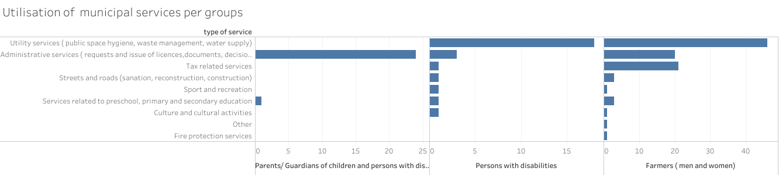

Figure 1.10.1: Utilisation of local services by three target groups

To determine the needs for improvement of local services in line with the needs of the persons with disabilities the survey collected responses on the same questions from all three target groups.
The results show that the prioritisation for improvement of services for persons with disabilities is differently perceived by the parents/ guardians and the persons with disabilities in comparison with farmers.

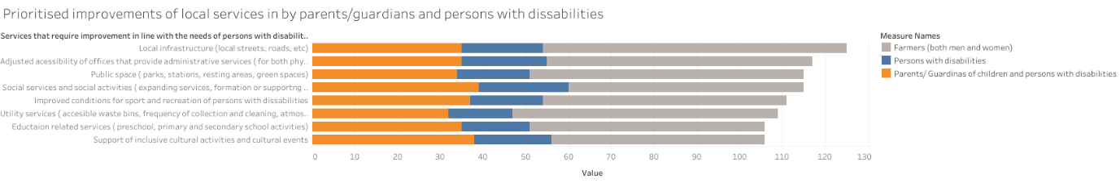
Figure 1.10.2 prioritesed inprovements of local services by all three target groups

The prioritised needs for improvement of the local services in line with the needs of the persons with disabilities have different priorities for the overall group and the farmers. While farmers put local infrastructure first, the parents/ guardians and persons with disabilities, put the provision of social services and social activities in terms of expanding the existing social services (in type, capacities and scale), formation of body or supporting existing NGOs for persons with disabilities in maintaining an inclusive and open club for socialisation or trainings delivery, etc.

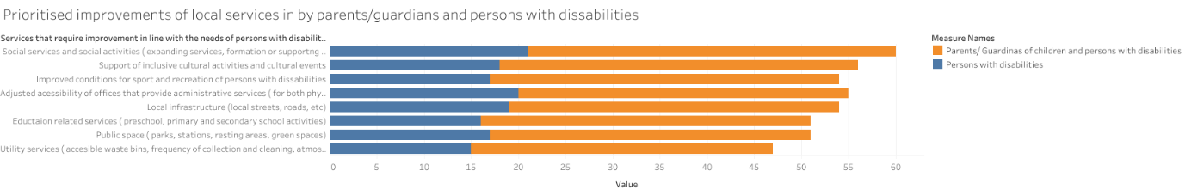
Figure 1.10.3 Prioritised imporvemnts of local services among parents/ guardians and persons with disabilities

The second priority includes support for inclusive cultural activities and cultural events which indicates again that the socialisation of the children and persons with disabilities is not on a satisfying level and contributes to their exclusion. Third prioritisation is given to improvement of access to administrative services on local level.

Most important for the purpose of this mapping process, are the priorities set by parents/ guardians of children and persons with disabilities are a bit different than the ones of the persons with disabilities overall.

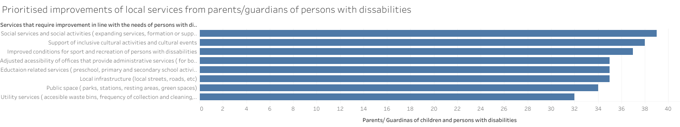
Figure 1.10.4 prioritised improvemnts indicated by parents. Guardinas in favour of children and dependants with disabilities

The first three priorities for children and persons with disabilities who have guardians are related to inclusive activities which are outside the home and include:

- Social services and social activities in terms of expanding the existing social services (in type, capacities and scale),
- Formation of consultative body or supporting existing NGOs for persons with disabilities in maintaining an inclusive and open club for socialisation or trainings delivery, etc
- Support of inclusive cultural activities and cultural events
- Improved conditions for sport and recreation of persons with disabilities

Followed by:

- Adjusted accessibility of offices that provide administrative services (for both physical and intellectual disabilities)
- Eductaion related services ( preschool, primary and secondary school activities)
- Local infrastructure (local streets, roads, etc)

There is a 100% agreement among the respondents for the need of public investments in improving the services on local level.

The findings about the conditions of the public space and issues specifically linked to persons with disabilities, correspond with the findings in the questions related to the local services. The summarised findings on the conditions are to reflect the community perspective and persons with disabilities perspectives. Since children with disabilities are priority group in this mapping process, the identified needs for improvements in public space will match the priorities set by parents/ guardians of children and persons with disabilities.
The conditions of the public space are evaluated through set questions related to: conditions of architectural accessibility, availability of green and public areas, and public space that provide opportunities for social /recreation/sport activities. The summary of conclusions from three groups identifies the architectural barriers as conditions that affect the public space and lack of adjusted space for inclusive activities.
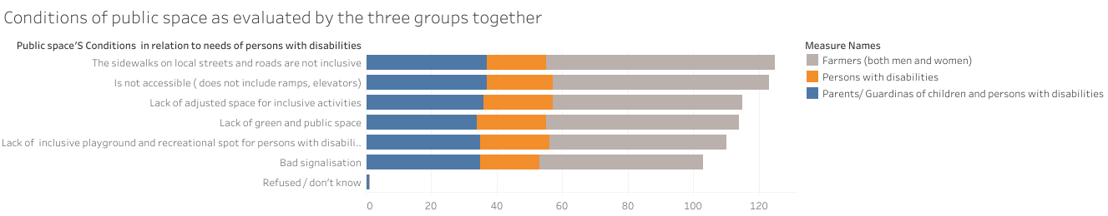
Figure 1.10.5

Persons with disabilities who personally provided responses to the survey identified bad conditions in public space that is crucial for the outdoor activities including the lack of green and public space, lack of inclusive space for inclusive activities, and lack of inclusive playground and inclusive recreational spot.
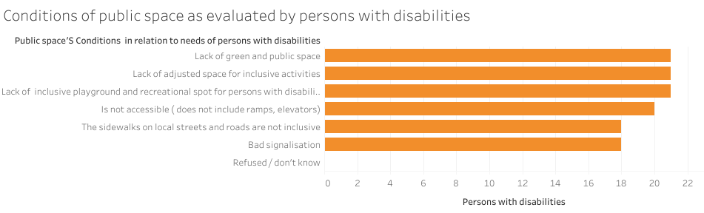
Figure 1.10.6

The architectural solutions to the local infrastructure as group are of secondary importance for them.

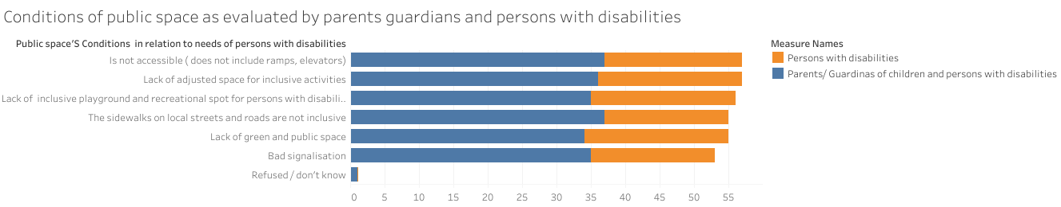
Figure 1.10.7
Parents/ guardians evaluated the public space as not architecturally inclusive putting priority to physical accessibility to:
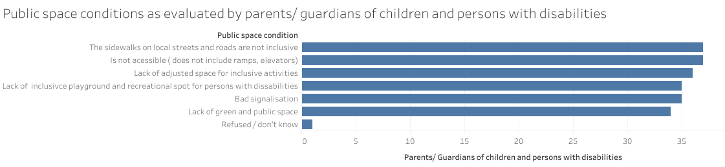
Figure 1.10.8
    - Sidewalks of local streets
    - Lack of elevators and ramps
    - Lack of inclusive public space for inclusive activities
    - Lack of inclusive playground and inclusive recreational spot
    - Bad signalisation
    - Lack of green and public space

COVID 19

In order to respond to the factor vulnerability to shocks the survey included questions in regards to the latest crises with COVID 19. The results are summarised from the three target groups together in order to see the effects of the pandemics and chow it affected the children and the persons with disabilities as well and the farmers. The COVID 19 conditions have not affected the persons with disabilities since they are unemployable and there are only 5 who are either part time employed or do seasonal or work in agriculture sector.

Figure 1.11.1 Employment status and COVID 19

During the survey the parents were particularly asked to respond on these questions for themselves.
In general terms the pandemics has changed the situation of persons with disabilities where the working hours were reduced.

Figure 1.11.2 Family income and COVID19

In terms of the financial effects on the families, COVID 19 affected the most family income of (21% of parents and guardians reported decrease of income) of children and persons with disabilities. Income of five percent (5%) of the families of persons with disabilities who personally responded to the survey was affected. Least affected was the income of families of women involved in agriculture and diversification activities (10%).

The families of children and adults with disabilities were most vulnerable during the COVID 19 crises due to the decrease of family income and parents’ guardian’s reduction of working hours. This situation affected the care for children which was additionally part of the survey.

Figure 1.11.3
Least affected were parents/ guardian of children and persons with disabilities since they take care of the children on everyday basis. The care increased for women and men in agriculture and for persons with disabilities who were left out of job.

The report uses google maps rather than tableau maps, since geotagging was made not online with Kobo but by selection of place of residence from the list. Tableau has not recognized the villages names in order to provide maps from that tool.
This section of analyses includes the following questions from the survey: Type of disability (according to UNICEF); How old was on the last birthday? Gender of the child or person? What is 's relationship to the head of household? What is 's marital status?
The fact is elaborated to the interviewer, and noted
28 721MKD, Source: https://www.stat.gov.mk/PrikaziSoopstenie.aspx?id=40&rbr=13708
"mean" is the "average" where you add up all the numbers and then divide by the number of numbers; “median" is the "middle" value in provided list of numbers; “standard deviation” is a measure of the amount of variation or dispersion of a set of values in this case the hours spent

